|  |  |  |  |  |  |
| --- | --- | --- | --- | --- | --- |
| Participants | : | Peter Schepens, Puneet Sabharwal, Umesh Kumar | Draft | : | 08/17/2023 |
| Not present | : |  |  |  |  |
| By | : | Patrick Goossens | Department | : |  |
| Copy to | : |  | |  |  |
| Next meeting | : | 17th August 2023 | | | |

|  |  |  |  |  |  |
| --- | --- | --- | --- | --- | --- |
| **Nr.** | **Type** | **Action/information only/decision (A/I/D)** |  | **By** | **Date** |
| 1 | A | Puneet to discuss internally what article code to use and where it should be created. We’ve discussed several options today (see below) |  | **Puneet** | **Completed** |
|  | D | **Option 1 (See 1. Article coding) to define extra article coding for experimental (trial) tyres in SAP is chosen to be the best solution.** |  | **Puneet & SAP team** |  |
| 2 | A | Umesh to find out what kind of non R&D data is being added to SAP for plant specifications |  | **Umesh** | **24-8** |
| 3 | A | Patrick to document the to be situation in Contact |  | **Patrick** | **WIP** |
| 4 | A | Patrick to schedule a weekly meeting |  | **Patrick** | **Done** |
| 5 | A | Work out multiple scenarios in the life cycle of a specification (birth, maintenance by R&D, maintenance by plant, out of production) |  | **Patrick** | **WIP** |
| 6 | A | Make an appointment with Hizmy to discuss the “brth of the article code” (slide 5) |  | **Patrick** | **24-8** |
|  |  |  |  |  |  |
|  |  |  |  |  |  |
|  |  |  |  |  |  |
|  |  |  |  |  |  |
|  |  |  |  |  |  |
|  |  |  |  |  |  |
|  |  |  |  |  |  |
|  |  |  |  |  |  |
|  |  |  |  |  |  |
|  |  |  |  |  |  |
|  |  |  |  |  |  |
|  |  |  |  |  |  |

1. Article coding:  
   Puneet has discussed the article coding and the birth of the coding with his team (e-mail attached).  
   The proposal is to create specific article codes in SAP for “normal” sales articles and for experimental (or trial) articles.   
   A diagram of a diagram

   Description automatically generated  
   Picture this as the to be situation. Every article in SAP ECC should be uniquely linked to one article in Contact. Today, in Interspec, we handle this by manually adding the SAP commercial article code to FG article codes in Interspec. For SFG, compounds and raw materials we are using the SAP commercial article code as the article code in Interspec. Sometimes there is the need for a translation table between Interspec and SAP coding).  
   This manual way of linking articles is due to give errors. When you add the wrong SAP article code to an Interspec FG article and interface it to SAP, it will overwrite this article in SAP.  
     
   So we need a way to automatically link the articles in both systems. And to the MES as well.  
     
   To do this, we discussed two options during previous meeting:
   1. Use one unique article code that can be used in all systems.   
      To be able to uniquely identify specifications per plant, and to tell whether they are experimental or production we would need some extra parameters.  
      To find a unique specification would require these 4 fields:
      1. Article code ( = SAP commercial article code )
      2. Plant ( = SAP plant code )
      3. Type ( = SAP material type ) – to separate experimental from production
      4. Unique identifier ( because there can be multiple experimental specs for one production spec )
   2. Use different article codes for experimental tyres. For instance: add an ‘X’ in front of the article code and a number at the end. You would still need a separate plant code.
      1. Article code ( = SAP commercial article code ) – experimental tyres would require their own article codes
      2. Plant ( = SAP plant code )
      3. Unique identifier ( because there can be multiple experimental specs for one production spec )

**In the meeting Puneet had with his team it was decided, option 1 would be the best solution.**

1. Birth of an article code:  
   related to the previous topic. What is the best system to generate the article code.  
   A diagram of a software company

   Description automatically generated  
     
   For RM and SFG, technically we can see two options. However, we can not take a decision. Patrick to ask Hizmy for guidance. Maybe we should also align with the business. But if so, with whom?

The options are:

* Option 1: R&D creates the new article, and article code, in Contact. Contact will ask SAP MDG to create the same code in SAP.
* Option 2: R&D creates the new article in SAP MDG. This would mean a change of process to Europe. In this case SAP MDG would tell both SAP ECC and Contact to create the same article with the same article code.

1. BoM:  
   BoM was discussed last week. Nothing new this week.
2. Masterdata:

**This is the point that Umesh needs to investigate. We discussed it last week:**

Another topic we touched was masterdata.   
We discussed the best system to store specific data. In our discussion today we isolated 2 specific types of data:

* 1. Data maintained by R&D
  2. Data maintained by plant for production (machine specific)

Currently in APMEA, this machine specific information is maintained in SAP and shown in production by printing a set of (approximately 20) paper forms.  
Currently in Europe it differs per plant:

* Enschede : stores extra machine information in PG (AS400)
* Hungary : retrieves information from Interspec, displayed by (or printed from) Athena

We think the best system to store this data in the future would be Contact, as SAP MDG is not capable of enriching with this kind of information.   
However, this was not in my original scope of the Contact system.   
I always imagined Contact to be the system holding R&D information and plant specific production information would be stored in a separate (plant production) system.

Next meeting:

We decided to keep doing this meeting on a weekly basis as long as necessary. And invite other colleagues to these meetings whenever required.

dd. 24-08-2023

Data-cleaning by Puneet (his reposibility), but approved by business.

Non-R&d-DATA like toolsets, etc. Wel/niet naar Contact.

Birth-day ArticleCode ?? Hizmy made decision to start article in CONTACT. For all the materials & SFG !!

What will trigger the data to be synced to SAP? = STATUS

What when we have to purchase raw-materials?

RM created in SAP en flowed to interspec.

SFG from IS to SAP

FG manually in SAP + IS.

Relation with product-hierarchy. We need an indicator to sync to SAP from CONTACT.

There is not an indicator !!!!

SPACEMASTER is SFG + FG.

Data implementation in MDG parallel aan CONTACT-migration.

Same product in EU and APMEA = XFG/CFG ??

5500/5M02 = XFG

SPECIFIC-PLANT-DATA to CONTACT !!

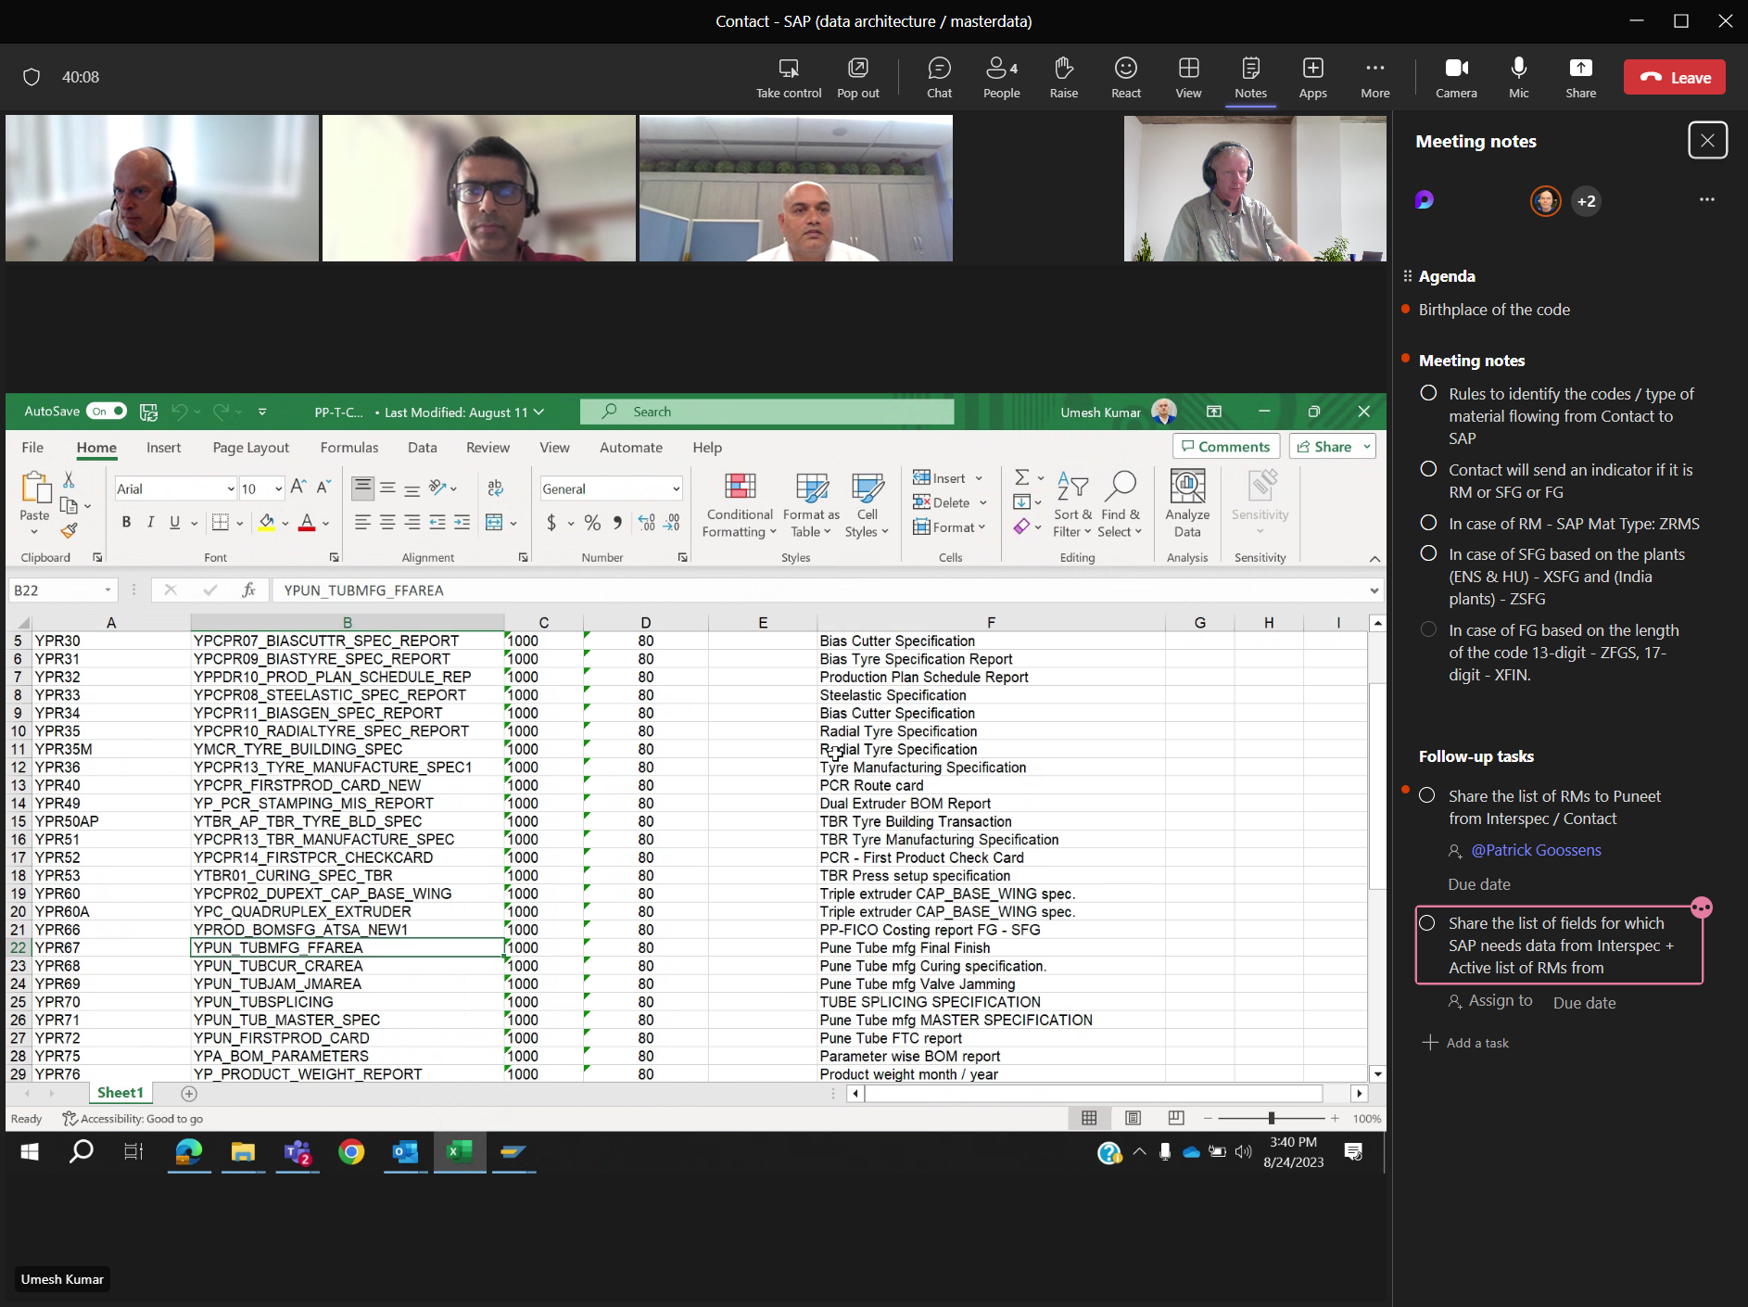

Sap-programs to maintain data in SAP

PRODUCT-HIERARCHY

